An Ancient Greek Soldier or Hoplite

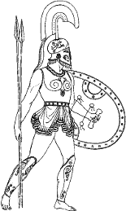
An Ancient Greek soldier was known as a Hoplite. He had to provide his own weapons and armour. A Hoplite’s weapons and armour were very simple and left large areas of the body unprotected, but worked well when he fought in a phalanx. Drag the text boxes to the correct arrow.
Bronze greaves (leg guards) to protect the lower part of the legs.
Bronze cuirass (breastplate) designed to protect the top part of the body.
Bronze helmet with long noseguard and cheekguards.
A Hoplite’s weapons were a long spear and short sword.
Large shield to protect the body.

